*Project Proposal*

**Group name:** Angry Pepe

**Group members:**

· Apoorv Joshi - 814003553

· Joshua O’Brien - 816001354

· Masood Khan - 05788124

**Project Name:** Kill it

**Project description:**

This software will allow users to have a controlled environment for an animal farm of any size and also a search and analysis database/ software of pests and diseases for farm animals locally and regionally.

The database would identify the type of disease the animal has, the different stages of the diseases as well as treatment options for the different stages of the diseases and where to find medication for said diseases.

The main objective of this project is to make a search and analysis software of pest and diseases of farm animals locally and regionally. The software made is going to be cross-platform software thus can run effectively in different environments enabling ease of use.

A person can search for various farm animal diseases with a search bar on the opened application. Once the user begins to input text into the search field they are presented with a drop list of search suggestions. This restriction allows the user to narrow and choose the content for which they are searching for. The software searches and analyzes the search and produces the outcome of the search.

The purpose of this software is aiding and arming the farmers with knowledge in identifying and mitigating the risk factors of pest and diseases of their livestock. This is extremely beneficial as they are able to make real time decisions based on the search outcome, thus reducing livestock losses due to spread of disease and securing their livelihood.

This software being made is a worthwhile, economically effective and reasonable endeavor. The data is easily stored in a cloud based environment therefore eliminating the need for buying and operating storage infrastructure. Information is readily available and accessible to users. Redundancy of data is greatly reduced. It also allows multiple users to access data. Data integrity is preserved as it ensures accuracy and consistency of data.

**Rationale for the project:**

In years gone farmers would observe their livestock having lesions or behaving strangely. By the time they are able to get help to figure out the cause, already their livestock would have taken a toll as they were unable to quickly identify the disease the animal was afflicted with. With the increase in technology, farmers would be able to search, analyze and identify the type of disease as well as the treatment options available utilizing our software, Kill It. This software is able to work across multiple device platforms as well as the software being user friendly.

**Business Benefits:**

* The software being made would be a product able to work across multiple device platforms. This enables ease of use for the user as the software is able to work efficiently in different environments without the user being constricted to one specific platform.

* The data is easily stored in a cloud based environment. This provides an economical advantage as it eliminates the need for buying, installing, operating and maintaining hardware storage infrastructure. Therefore server failures that cause downtime would no longer be an issue as information becomes readily available and accessible to users and also allows multiple users to access data. Data integrity is preserved as it ensures accuracy and consistency of data.
* Farmers utilize and benefit from the software technology with the software being able to analyze and identify the disease if their animals become afflicted. The software is able to identify and show treatment options available for the disease and its various stages. This results with the farmer being able to make real time decisions, containing any contagious diseases thereby mitigating the possibilities of outbreak and securing their livelihood.

**Stakeholders :**

User stakeholders: (Who will be using the system?)

The targeted users include but are not limited to

* Agricultural industry

Non-user stakeholders: (Who will not be directly using the system but benefits from the system?)

**User Environment: (Environment refers to the collection of hardware and software tools a system developer uses to build software systems.)**

* Android Operating System Firmware Version Oreo 8.1.0 (API 27) and upwards
* iOS 12 and upwards
* Android Studio

**Alternatives and Competition to your solution: (Are there ways the problem can be solved? Are there already products on the market that provide a solution? If yes what are they?)**

There is a product called

**Estimated Project Duration**

The project will be developed using a plan-driven strategy and is expected to be completed within 12 weeks.

**For each group member**

**Key skills (e.g. Databases, Web programming, etc.) –**

Apoorv Joshi - System Architecture Designer, MySQL database designer

Masood Khan - Mobile Application Programmer, Database Manager

Joshua O’Brien - Web programming, Design and analysis

**How each member contributes to the project**

* Joshua: Design a user friendly interface focused on maximizing usability and user experience
* Apoorv: Designing the system’s architecture to accommodate the best user experience.
* Masood: Implementing the backend and testing.
* All members will contribute towards the research and documentation.

**Statement of how you plan to work together (When you will meet, Collaboration tools you will use)**

Twice every week on Wednesdays and Saturdays at face to face conferences. The use of online collaboration tools such as google docs and whatsapp would be used to communicate on a regular day to day basis.

**User story 1**

The user opens the application and sees a search bar option available for searching. The user is able to type in " cattle disease " in the search bar where a drop list of search suggestions is presented to aid in spell checking and narrowing the field of search. Search type comes up with the name of the different types of diseases for different species of cattles locally and regionally along with images of the infected cattle. The searches returned in alphabetical order. User is then able to click on either the name of the disease or the pictures of the cattle. This action gives further details on the type and stages of the disease as well as treatment options available to treat the various stages of the disease or if cattle needs to be disposed off, if it's beyond medication as well as information on ethical ways of disposing of the cattle.

**User story 2**

The user is able to open the application on any smartphone with a built-in camera where there is an option available to take a picture of the animal. The user is able to take a picture and crop the image of the animal where the software will detect and aid in guiding the user in cropping the infected part of the animal . After cropping the image of the animal, the user is then able to send the image of the animal to the software database for analysis. The results of the analysis returns along with information identifying the type and stages of the disease as well as the veterinarian qualified to treat the disease. The user is able to tap on the veterinarian name thereby getting detailed information on the veterinarian name, address of veterinary clinic and contact information.

User story 3

**Functional Requirements**

User Functional Requirements:

**Nb: specimen - plant,soil or other type of vegetation.**

1. The user shall be able to create an account.
2. The user shall be able to log into an existing account.
3. The user shall be able to upload a picture of the specimen to be analyzed.
4. The user shall be able to search the database for specific diseases, treatments and medications for a specific specimen.
5. The user shall be able to get further help from a professional when needed.

System Functional Requirements:

1. The system shall allow the user to create an account whereby providing an email address, contact number and a password.
2. The system shall allow the user to log into the system whereby providing their email address and password.
3. The system shall allow the user to update their password and contact information.
4. The system shall allow the user to take a picture using the device’s inbuilt camera and upload it to be analyzed.
5. The system will send a confirmation email to the user once a picture has been uploaded.
6. The system will email a detailed report to the user describing the type of disease, severity of the disease, possible treatments and where medication can be found.
7. The system will allow the user to query for information from the database which returns results based on popularity and alphabetical order.
8. The system shall be able to search the database by using the kill it software for data on a specific specimen.
9. The system shall allow the user to be able to upload a picture of a specimen to the kill it software which will then analyse the picture to give a response on whether or not there is information available in the database.
10. The system shall allow a user to be able to get additional help from a professional when a query to the database returns unsatisfactory results.
11. The system shall allow a user to be able to create a new account by entering a username using their email address and password.

**Non Functional Requirements**

1. The system shall email a detailed report to the user within 24 hours.
2. The software shall be able to allow users to login to the system using their username and password within a maximum time of two minutes.
3. The software shall be able to upload a maximum image size of 1 megabyte.
4. The software shall be able to complete analysis of the uploaded image by searching the database in at most three minutes.
5. The software shall be able to query the database for information in a maximum time of thirty seconds.

**USE CASES**

The **user** will be able to:

1. Register for the service
2. Upload a picture
3. Search the database

The **professional** will be able to:

1. Register for the service
2. Query feedback
3. Contact the user for clarification
4. Request a database update if new information is found.

The **database** will be able to:

1. Provide detailed information (disease, treatment, medication, etc)

The **system admin** will be able to:

1. Update the database
2. Notify the professional for verification.

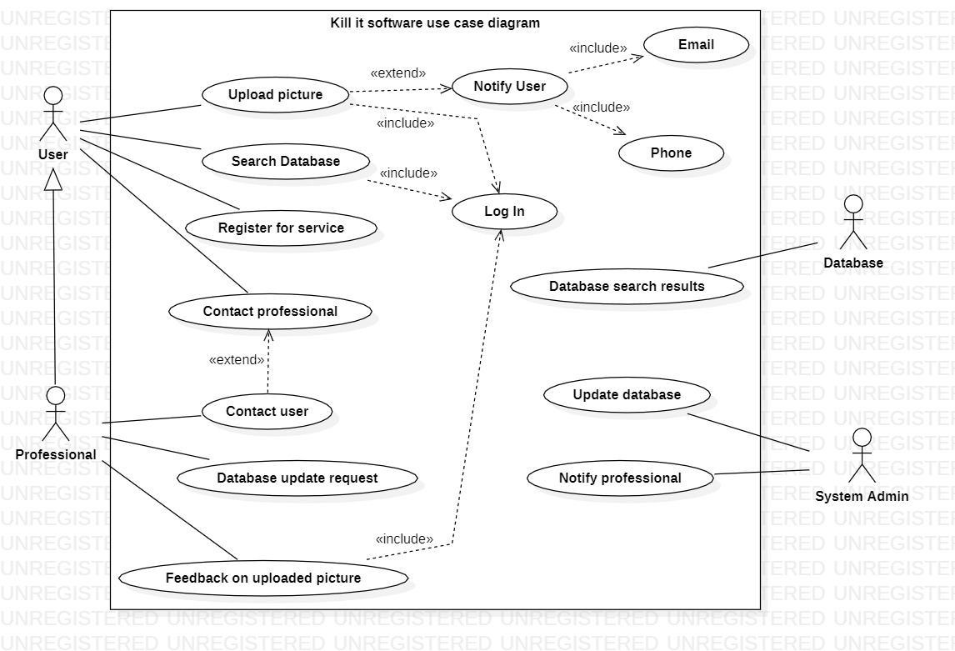

**Use case ranking and priority matrix**

The use case ranking and priority matrix is a tool used to evaluate use cases and determine their priority on a 1-5 scale against six criteria.

1. Significant impact on the architectural design.

2. Easy to implement but contains significant functionality.

3. Includes risky, time-critical, or complex functions.

4. Involves significant research; new or risky technology.

5. Includes primary business functions.

6. Will increase revenue or decrease costs.

|  |  |  |  |  |  |  |  |  |  |
| --- | --- | --- | --- | --- | --- | --- | --- | --- | --- |
| Use case name | Ranking criteria, 1-5 | | | | | | Total score | Priority | Build cycle |
|  | 1 | 2 | 3 | 4 | 5 | 6 |  | | |
| Register for service | 5 | 5 | 1 | 1 | 3 | 3 | 18 | Medium | 1 |
| login | 5 | 5 | 1 | 1 | 3 | 3 | 18 | Medium | 2 |
| Search database | 4 | 4 | 4 | 1 | 5 | 5 | 23 | High | 3 |
| Upload picture | 4 | 5 | 3 | 1 | 5 | 5 | 23 | High | 4 |
| Feedback on uploaded picture | 3 | 5 | 2 | 1 | 5 | 2 | 18 | High | 5 |
| Database search results | 5 | 1 | 4 | 2 | 3 | 1 | 16 | High | 5 |
| Contact User | 3 | 3 | 4 | 1 | 3 | 1 | 15 | Medium | 6 |
| Contact Professional | 3 | 2 | 3 | 1 | 1 | 1 | 11 | Low | 6 |
| Request database update | 2 | 5 | 2 | 1 | 1 | 2 | 13 | Medium | 7 |
| Update database | 2 | 2 | 2 | 1 | 2 | 1 | 10 | High | 8 |
| Notify professional | 1 | 1 | 1 | 1 | 1 | 1 | 6 | Low | 9 |

**EXPANDED USE CASE AND SEQUENCE DIAGRAM**

Expanded Use Case

Kill It System

|  |  |
| --- | --- |
| Author(s): Apoorv Joshi  Joshua O’Brien  Masood Khan | Date: 18th March 2019  Version: 1.0 |

|  |  |  |
| --- | --- | --- |
| **Use-Case Name** | Search Database | Use-Case Type: Business |
| **Use-Case-ID** | 4 |
| **Priority** | High |
| **Source** |  |
| **Primary Business Actor** | User | |
| **Other Participating Actors** | Professional | |
| **Other Interested Stakeholders** | Professional - Interested in information authenticity. | |
| **Description** | This use case describes the event of a user uploading a picture of the pest or disease affecting their farm. Upon uploading the picture, the notification system notifies the user via email or text message. The uploaded picture is then in a queue waiting to be analysed by a professional. | |
| **Precondition** | The user must be registered for the service. | |
| **Trigger** | Initiated when the user uploads a picture. | |
| **Typical Course of Events** | **Actor Action** | **System Response** |
| Step1: The user uploads a picture to the database. | Step 2: The database sends a confirmation to the Notification System.    Step 3: The Notification System sends a notification to the user via email or text message, depending on the user’s preference. |
| **Alternative Courses** |  | |
| **Conclusions** | Concludes when the system notifies the user. | |
| **Post-condition** | The Professional, based on their opinion, sends the user a feedback report on the picture uploaded. | |
| **Business Rules** | Availability of professionals may affect the amount of time taken to get feedback to the user. | |
| **Implementation Constraints and Specifications** | The size of the image uploaded by the user must not exceed the specified size. | |
| **Assumptions** |  | |
| **Open Issues** |  | |

**Sequence Diagram** for the use case with the highest score.

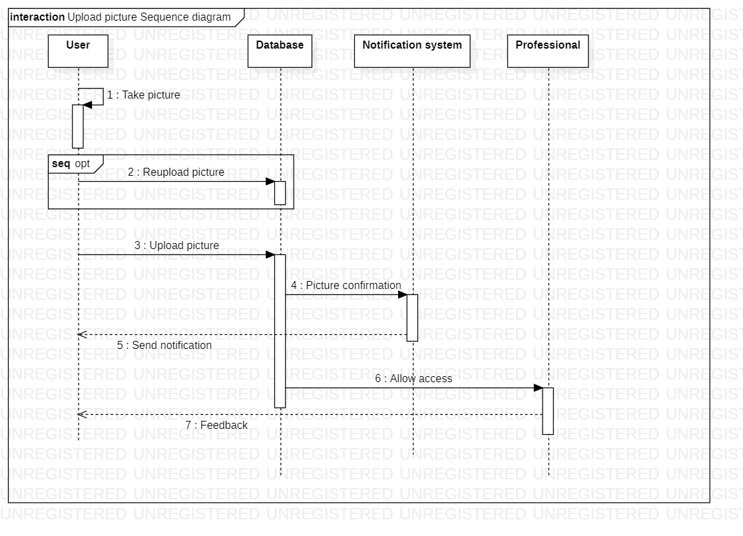

**Class diagram**

